AI ASSISTED CODING

LAB– 9.2

NAME:A.DINESH

ENROLL.NO:2403A52080

BATCH:04

**Task-1:**

(Documentation – Google-Style Docstrings for  
Python Functions)  
• Task: Use AI to add Google-style docstrings to all functions in a  
given Python script.  
• Instructions:  
o Prompt AI to generate docstrings without providing any  
input-output examples.  
o Ensure each docstring includes:  
▪ Function description  
▪ Parameters with type hints  
▪ Return values with type hints  
▪ Example usage  
o Review the generated docstrings for accuracy and  
formatting.  
• Expected Output #1:  
o A Python script with all functions documented using  
correctly formatted Google-style docstrings

**Prompt:**

Add Google-style docstrings to all functions in a given Python script.

Ensure each docstring includes: Function description, Parameters with type hints, Return values with type hints

**Code:**

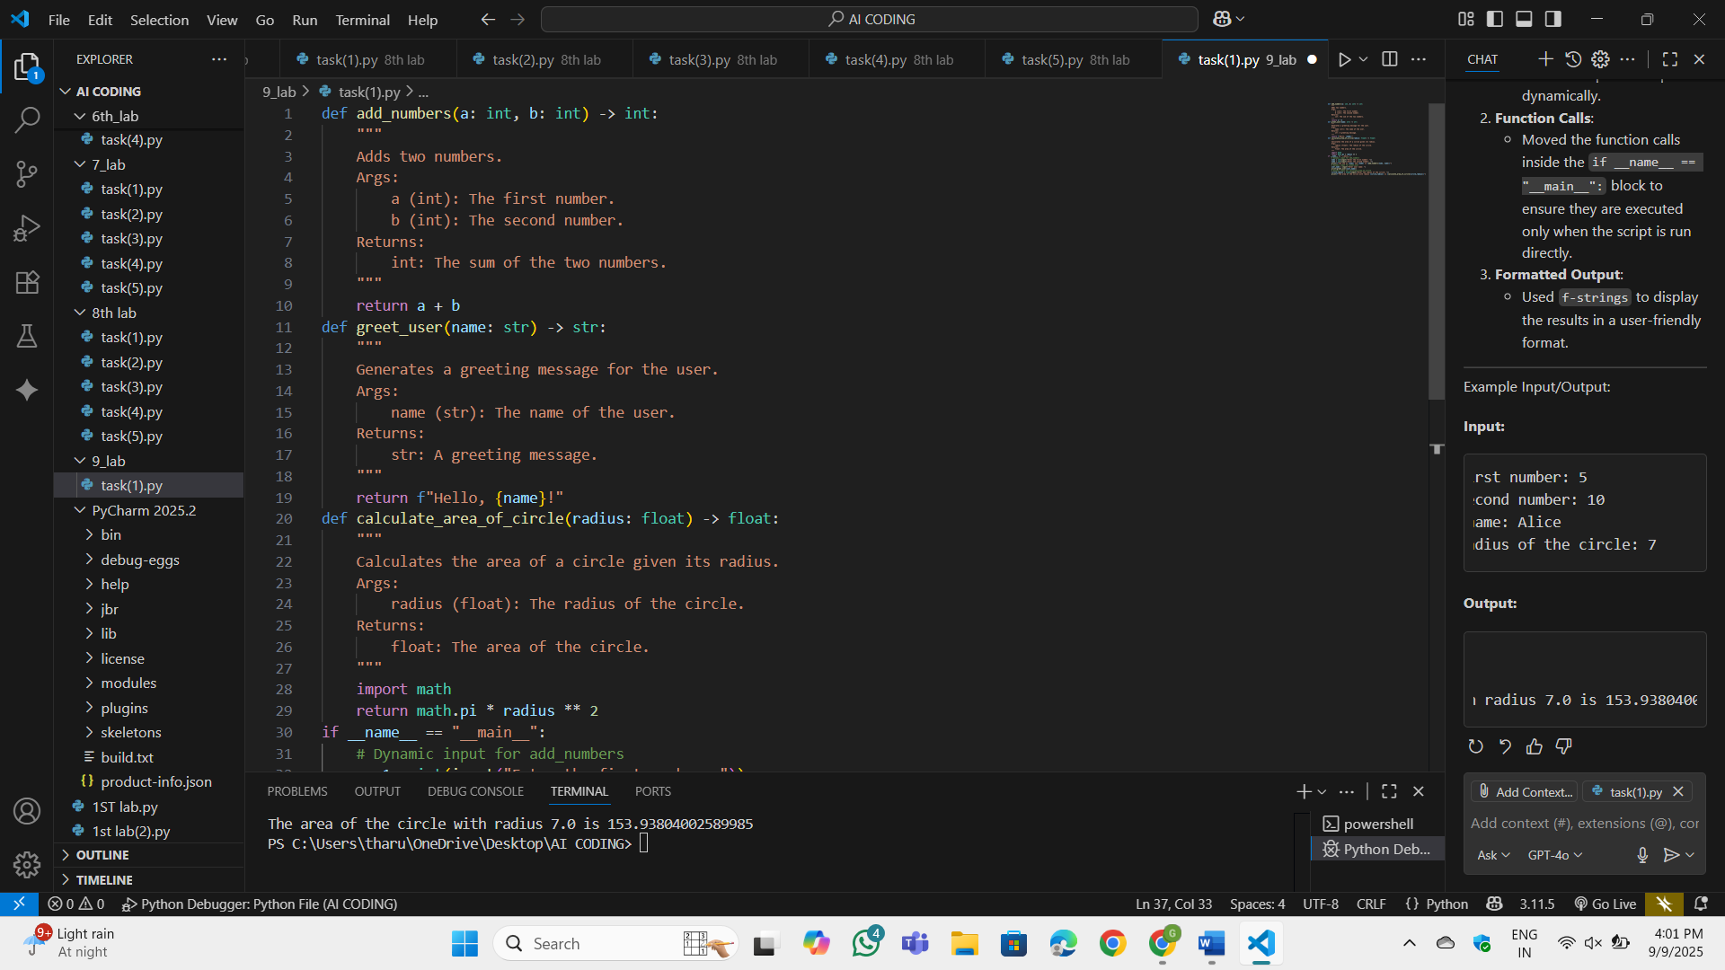

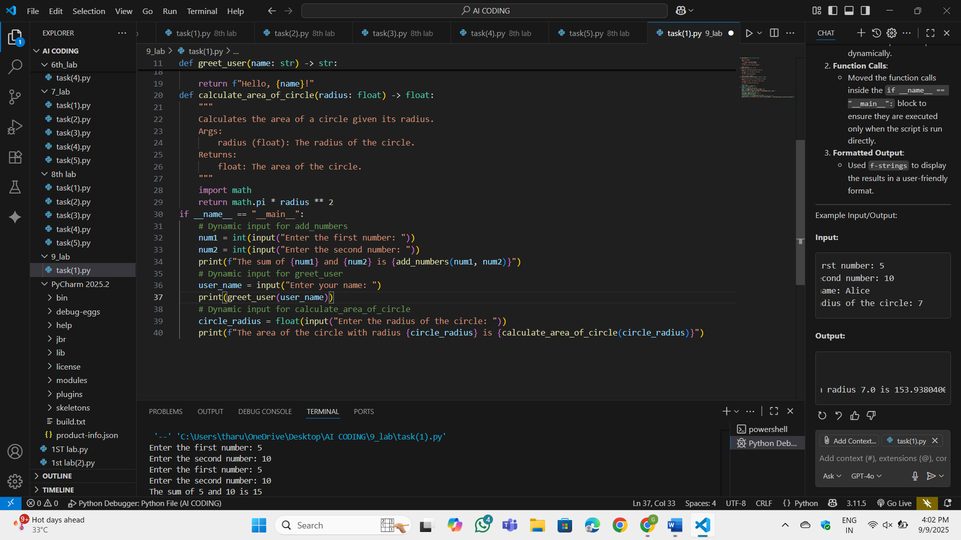

**OUTPUT:**

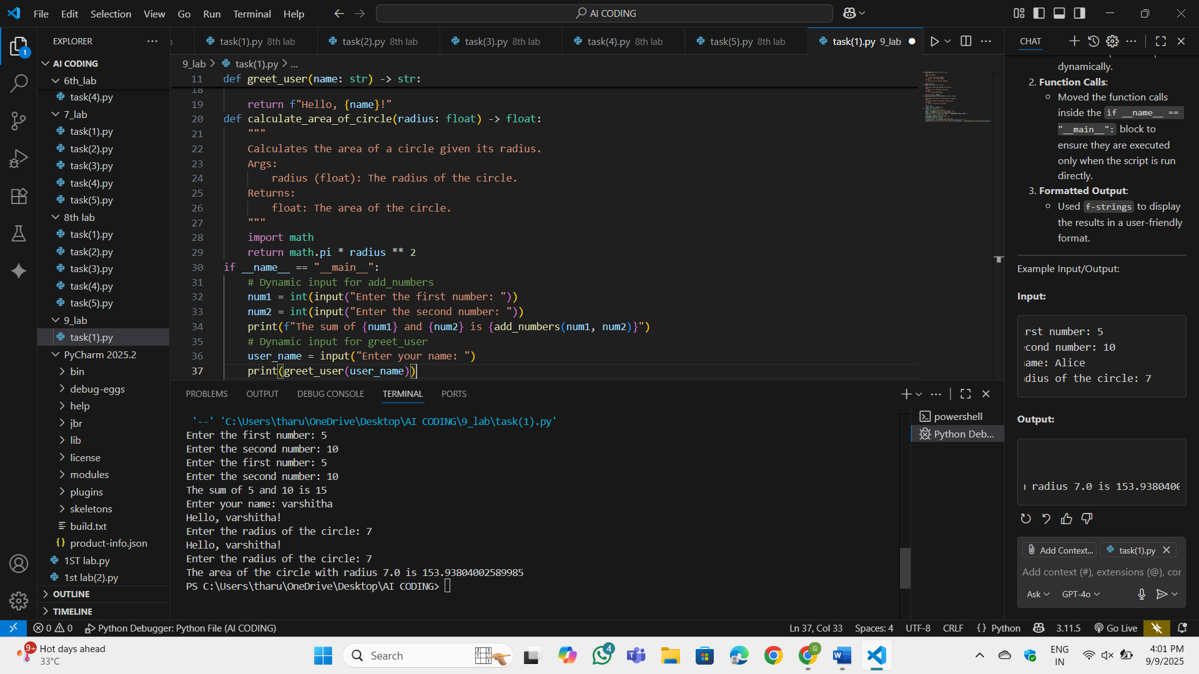

**Observation:**

Added input() prompts for each function to allow the user to provide input dynamically. Moved the function calls inside the if __name__ == "__main__": block to ensure they are executed only when the script is run directly. Used f-strings to display the results in a user-friendly format.

**Task-2:**

(Documentation – Inline Comments for Complex  
Logic)  
• Task: Use AI to add meaningful inline comments to a Python  
program explaining only complex logic parts.  
• Instructions:  
o Provide a Python script without comments to the AI.  
o Instruct AI to skip obvious syntax explanations and focus  
only on tricky or non-intuitive code sections.  
o Verify that comments improve code readability and  
maintainability.  
• Expected Output #2:  
o Python code with concise, context-aware inline comments  
for complex logic blocks

**Prompt :**

For the code I provided focus only on tricky or non-intuitive code sections. And add meaningful inline comments to a Python program explaining only complex logic parts  
**Code:**

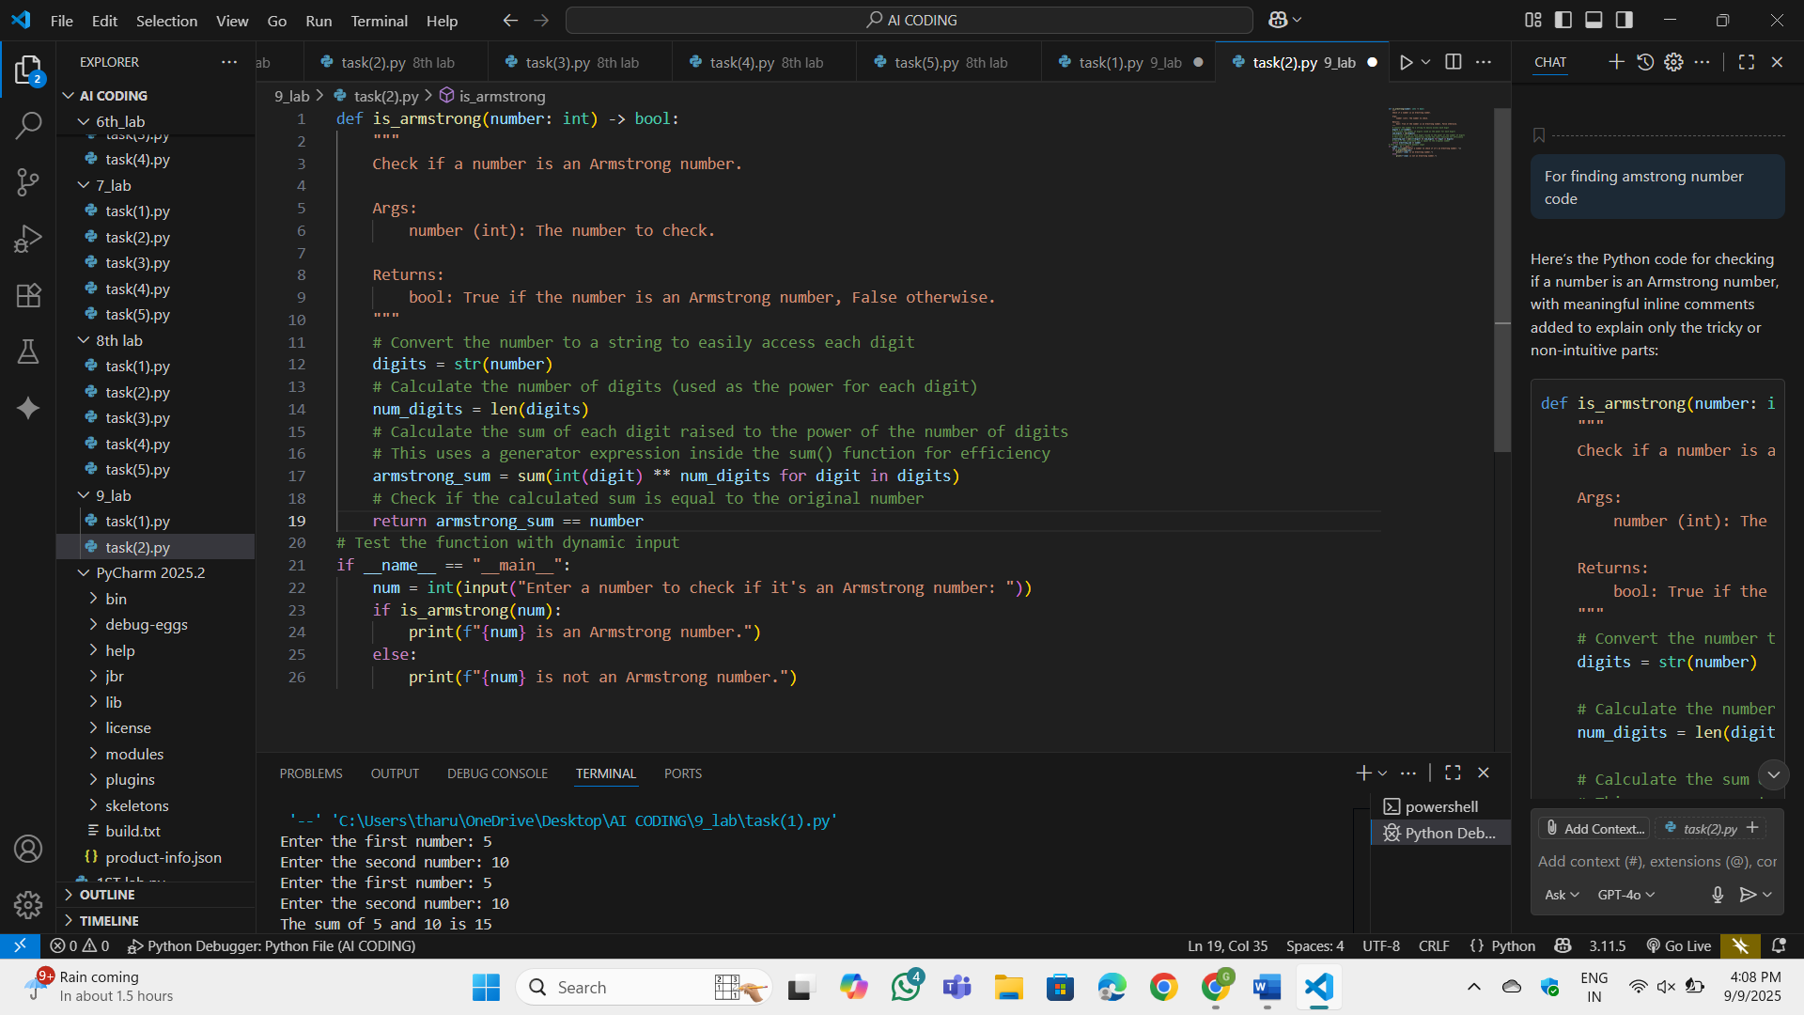

**OUTPUT:**

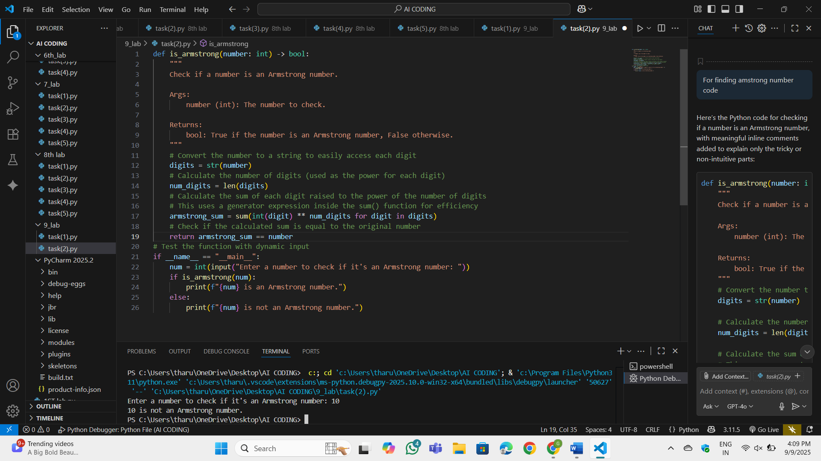

**Observation:**

digits = str(number): Converts the number to a string to allow iteration over its digits. num_digits = len(digits): Calculates the number of digits in the number, which determines the power to which each digit is raised. sum(int(digit) ** num_digits for digit in digits): Uses a generator expression to calculate the sum of each digit raised to the power of num_digits. This avoids creating an intermediate list, making the code more memory-efficient. return armstrong_sum == number: Compares the calculated sum to the original number to determine if it’s an Armstrong number

**Task-3:**

(Documentation – Module-Level Documentation)  
• Task: Use AI to create a module-level docstring summarizing the  
purpose, dependencies, and main functions/classes of a Python  
file.

• Instructions:  
o Supply the entire Python file to AI.  
o Instruct AI to write a single multi-line docstring at the top  
of the file.  
o Ensure the docstring clearly describes functionality and  
usage without rewriting the entire code

**Prompt:**

For the given code describes functionality and  
usage without rewriting the entire code

**Code:**

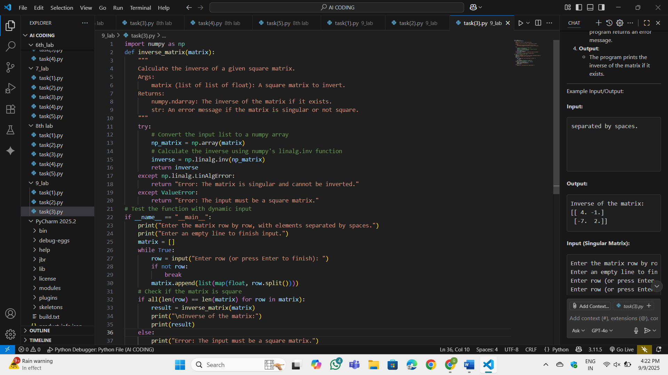

**OUTPUT:**

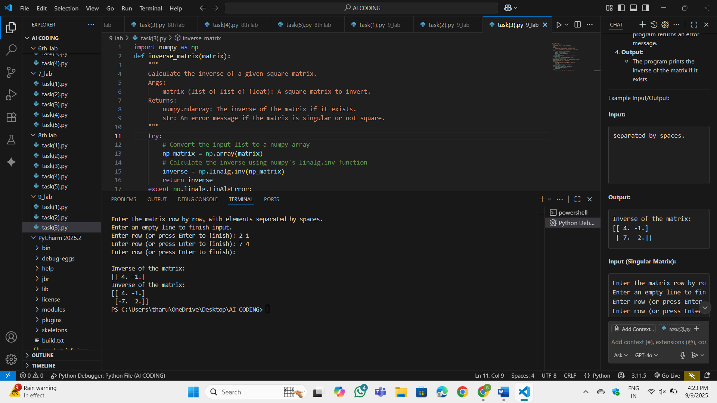

**OBSERVATION:**

The numpy library is used for matrix operations. The np.linalg.inv() function calculates the inverse of a matrix. The user inputs the matrix row by row. The input is converted into a list of lists, where each inner list represents a row. If the matrix is not square, the program returns an error message. If the matrix is singular (determinant = 0), the program returns an error message. The program prints the inverse of the matrix if it exists.

**Task-4:**

(Documentation – Convert Comments to  
Structured Docstrings)  
• Task: Use AI to transform existing inline comments into  
structured function docstrings following Google style.  
• Instructions:  
o Provide AI with Python code containing inline comments.  
o Ask AI to move relevant details from comments into  
function docstrings.  
o Verify that the new docstrings keep the meaning intact  
while improving structure.  
• Expected Output #4:  
o Python code with comments replaced by clear,  
standardized docstrings

**Prompt:**

convert Comments to Structured Docstrings for the code which I provided.

**Code:**

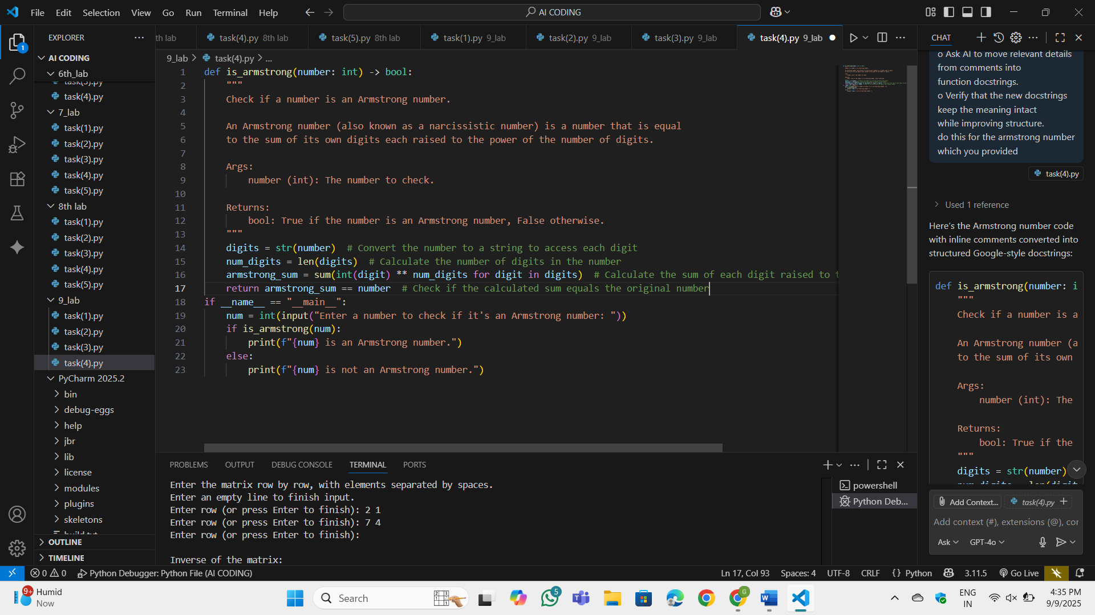

**OUTPUT:**

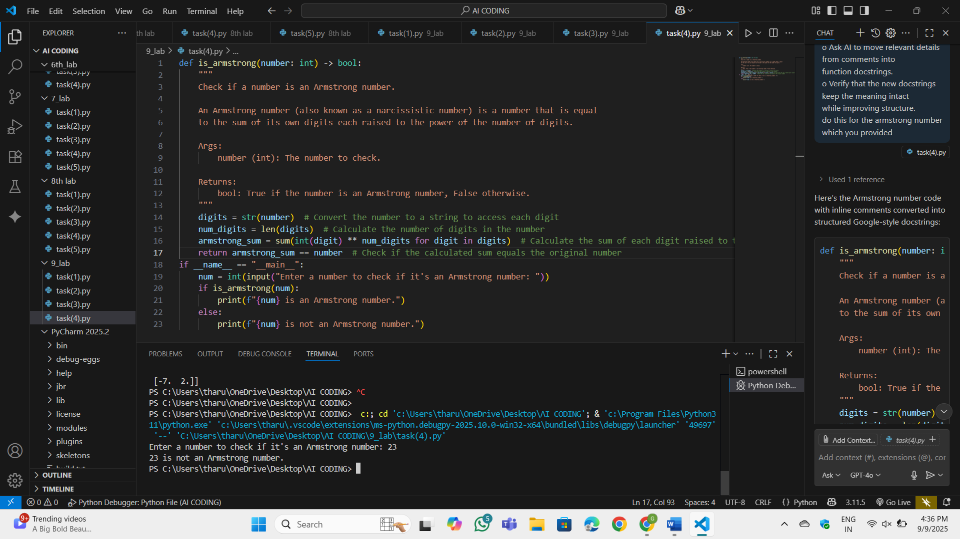

**OBSERVATION:**

Removed inline comments from the code. Added a detailed docstring to the is_armstrong function. The docstring explains: **Purpose**: What the function does. **Args**: The input parameter and its type. **Returns**: The return value and its type. **Logic**: A brief explanation of the Armstrong number concept. The docstring improves the structure and readability of the code while keeping the meaning intact

**Task-5:**

(Documentation – Review and Correct  
Docstrings)  
• Task: Use AI to identify and correct inaccuracies in existing  
docstrings.  
• Instructions:  
o Provide Python code with outdated or incorrect  
docstrings.  
o Instruct AI to rewrite each docstring to match the current  
code behavior.  
o Ensure corrections follow Google-style formatting.  
• Expected Output #5:  
o Python file with updated, accurate, and standardized  
docstrings

**Prompt:**

Identify and correct inaccuracies in existing docstrings.

**Code:**

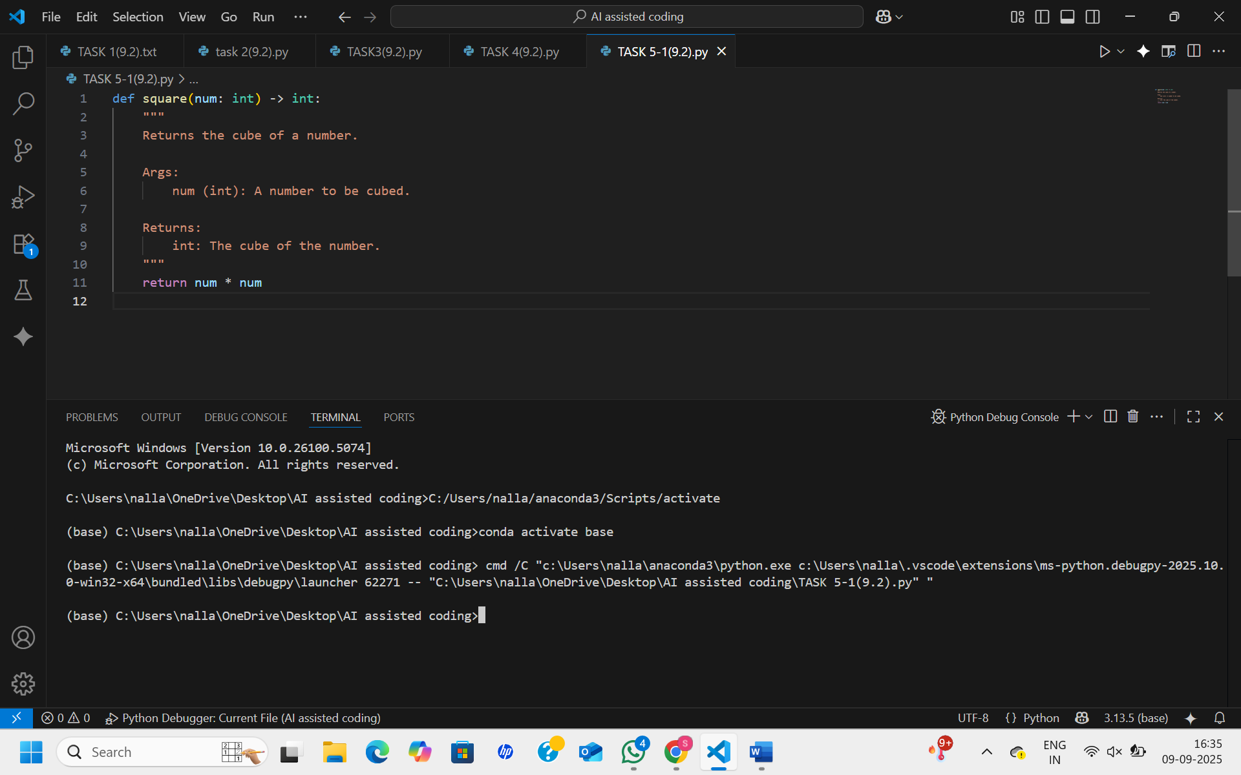

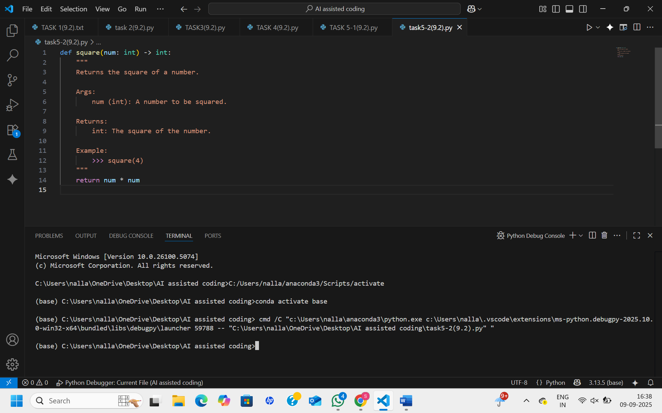

**OUTPUT:**



**OBSERVATION:**

The main issue is docstring drift—the code changes but the documentation doesn’t. Correcting the docstrings to Google style makes the functions clearer, accurate, and easier to maintain

**Task-6:**   
(Documentation – Prompt Comparison  
Experiment)

• Task: Compare documentation output from a vague prompt and a  
detailed prompt for the same Python function.  
• Instructions:  
o Create two prompts: one simple (“Add comments to this  
function”) and one detailed (“Add Google-style docstrings  
with parameters, return types, and examples”).  
o Use AI to process the same Python function with both  
prompts.  
o Analyze and record differences in quality, accuracy, and  
completeness.  
• Expected Output #6:  
o A comparison table showing the results from both  
prompts with observations

**Prompt:**

Compare documentation output from a vague prompt and a  
detailed prompt for the same Python function. Create two prompts: one simple (“Add comments to this function”) and one detailed (“Add Google-style docstrings with parameters, return types, and examples”).

**Code:**

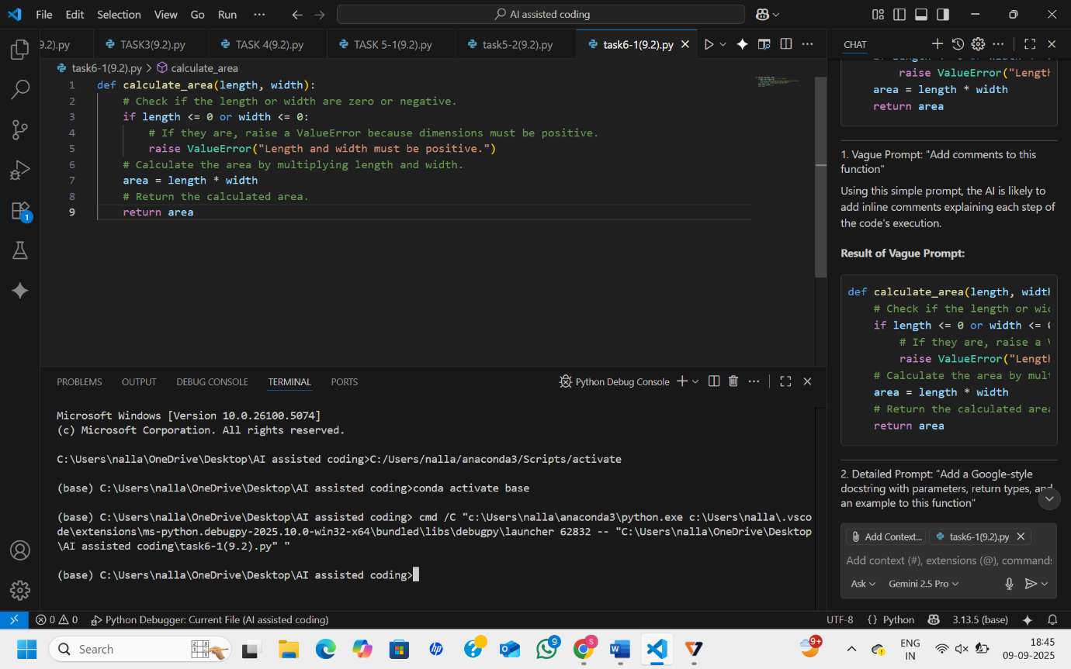

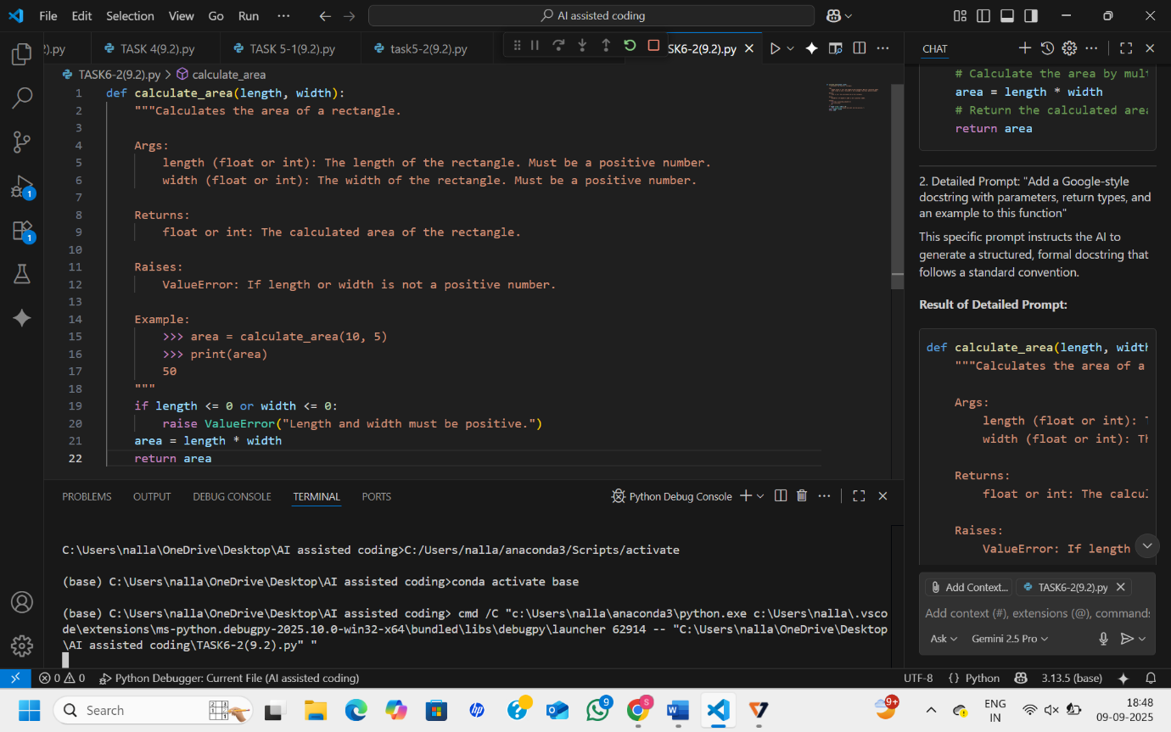

**Observation:**

A detailed and specific prompt yields a vastly superior documentation result. It moves beyond simple line-by-line explanations to create structured, comprehensive, and professional documentation that significantly improves code maintainability and usability.